COLLEGE OF HEALTH SCIENCES AND TECHNOLOGY, 

IJERO-EKITI, EKITI STATE

P.M.B. 316 IJERO-EKITI

portal.chstechijero-edu.ng

Office of the Registrar

Dear Mr./Mrs./Miss: ..............................................

Registration Number: ..................................................

**OFFER OF PROVISIONAL ADMISSION FOR 2021/2022 ACADEMIC SESSION**

With reference to your application for admission and subsequent interview you attended at the COLLEGE OF HEALTH SCIENCES & TECHNOLOGY, IJERO-EKITI, EKITI STATE, NIGERIA, I am pleased to inform you that you have been offered a provisional admission into the College for the 2020/2021 ACADEMIC SESSION to study............................................................................................... Course leading to the award of Diploma/Certificate for......................

1. MODE OF ENTRY: Entrance Examination

2. COURSE OFFERED: .............................................

3. SCHOOL: ................................................................

4. DURATION: ...........................................................

5. STATE OF ORIGIN: ..............................................

6. FEES: ......................................................................

**100 LEVEL INDIGINE NON-INDIGINE**

**PARTICULARS ~~N~~ ~~N~~**

**A. ACCEPTANCE FEE**  **25,000.00 25,000.00**

**B. COMPULSORY PAYMENTS**

i.HOSTEL ACCOMMODATION 35,000.00 35,000.00.

ii. MEDICAL 15,000.00 15,000.00

iii. UNIFORM 15,000.00 15,000.00

iv. INDEXING 20,000.00 20,000.00

**SUB-TOTAL 85,000.00 85,000.00**

**C**. **TUITION:**

**CATEGORIES**

1. **CHEW, PHARMARCY, MEDICAL LAB, X-RAY**

**HIM TECHNICIAN, AND DOP 130,000.00 140,000.00**

1. **HIM TECH, CHEW TECH, EHT,**

**DENTAL TECHNICIAN, BME, PARAMEDICS**

**AND ORTHOPEADIC PLASTERING. 110,000.00 120,000.00**

1. **HUND, EVT, COMPUTER, EHA**

**PUBLIC HEALTH TECHNICIAN,**

**FOOD HYGIENE, PHN,**

**HEALTH EDUCATION, OCCUPATIONAL**

**HEALTH AND SAFETY. J-CHEW 95,000.00 105,000.00**

1. **Category A**

**60% Part Payment 78,000.00 84,000.00**

**40% Part Payment 52,000.00 56,000.00**

1. **Category B.**

**60% Part Payment 66,000.00 72,000.00**

**40% Part Payment 44,000.00 48,000.00**

1. **Category C**

**60% Part Payment 57,000.00 38,000.00**

**40% Part Payment 63,000.00 42,000.00**

02.Students should note that they shall pay the above tuition fee annually throughout the duration of the programme.

03.I wish to add that this offer of admission is subject to the following conditions:

1. All fees should be dully paid online through **College Portal** and receipt obtained and verified by the Bursary Office of the College before proceeding for registration as a student.
2. The acceptance fee must be paid within two (2) weeks, otherwise the offer of provisional of admission shall be forfeited.
3. The payments in A and B above must be paid before you will be allowed for central screening and online registration.

04. You are to report at the Admission Office for central registration with your original certificates after the payment of the acceptance fee and Eight Thousand Naira (~~N~~80,000.00) for Hostel Accommodation, Medical Test, Uniform and Indexing with your Admission letter and Medical Certificate from the COLLEGE OF HEALTH SCIENCES & TECHNOLOGY Health Centre within fourteen (14) days.

05. Photocopies of all credentials including a letter from a Guarantor should be submitted to the Admission Office of the College.

06. You are to thereafter, proceed with a clearance obtained from Admission office to your School and department for further registration respectively.

07. Registered Students shall be presented for Probation/Weeding and Mid-semester exam within 3 months of resumption and if found unsuitable, will be advised to withdraw without any refund of any payment.

08. Any Student found pregnant during the course of study will be asked to withdraw from the College with immediate effect.

09. Students shall pay the cost of their industrial training, practicals, books, study equipment, departmental activities, and accreditation levy and pay all Professional Councils/Boards Charges.

10. **Other Materials to be submitted include:**

1. Six (6) copies of passport sized photograph,

2. Four (4) photocopies of each statement of result or certificate,

3. Four (4) photocopies of admission letter

4. Four (4) photocopies of Birth Certificate or Declaration of age

5. Four (4) photocopies of Marriage certificate if applicable.

11. You are advised to bring along your laptop dully registered with the College Security while resuming.

12. You will be guided by your HOD on how to proceed on course registration online while lectures start in accordance with academic calendar displayed on the portal and notice Boards.

13. It should be noted that if it is discovered hereafter that you do not possess any of the qualifications on which the offer of admission was granted, you will be required to withdraw from the program with immediate effect.

14. Accept my congratulations.

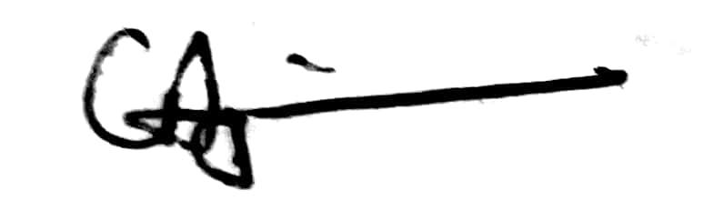

C. A. Ogunsakin (Mrs)

Registrar